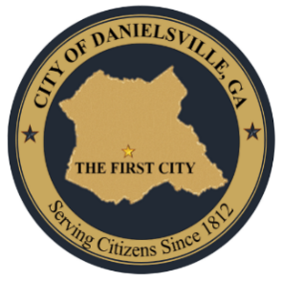
Mayor Michael Wideman
Council Member Steve Russum
Council Member Dona Miller
Council Member Nancy Federico
Council Member Cyle Cox
City Clerk Kimberly Davis
Police Chief Eric Cook
Maint. Supervisor Neat Davis

CITY OF DANIELSVILLE
10 Government Cir
Danielsville, Ga 30633
Office (706) 795-2189 Fax (888) 295-1935

^{April 13, 2026 – 7pm}

SPECIAL CALLED MEETING
MINUTES

1. CALL MEETING TO ORDER
A. Welcome - Mayor Michael Wideman welcomed everyone to the Public Hearing Meeting at 7pm. Wideman asked everyone to stand for the pledge and he announced roll call as follows: Himself, Mayor Michael Wideman, Council Member Steve Russum, Council Member Nancy Federico, Council Member Cyle Cox, Council Member Dona Miller, Police Chief Eric Cook, City Clerk Kimberly Davis, Maintenance Supervisor Clarence Davis and City Attorney Bubba Samuels.
B. Alcohol License for Hari Hara Hospitality, LLC DBA Sunoco - Mayor Wideman stated that Hari Hara Hospitality, LLC has purchased the Danielsville Sunoco and are now requesting an alcohol license. Mayor Wideman asked City Clerk Kimberly Davis if all requirements have been met for this request, and she confirmed that they have.

2. ADJOURNMENT
A. Mayor Wideman asked for a motion to leave the Public Hearing Meeting and enter into the Regular Business Meeting. A motion was made by Council Member Steve Russum and a second was made by Council Member Dona Miller. All in favor was unanimous. We entered into the Regular Business Meeting at 7:04pm

_____________________________________ ________________________________
Mayor, Michael Wideman Council Member Steve Russum

_____________________________________ _________________________________
Council Member Dona Miller Council Member, Cyle Cox

____________________________________ _________________________________
Council Member Nancy Federico City Clerk Kimberly Davis

(City Seal)

